QUESTIONNAIRE
- Adding a Questionnaire
  - Timing
  - Response Options
  - Content Options
- Advanced Settings
  - Content Options
  - Submission Options
- Adding Questions
  - Editing Questions
  - Common Options
  - Conditional Branching Feature
  - Question Types
  - Manage Questions
  - Conditional Branching (Extended)
    - Operations on Conditional Branching
  - Previewing Questionnaire
  - Individual Responses Report
- Viewing Questionnaire Responses
  - All Responses
  - Your Responses
  - Show Non-Respondents
- Personality Test
  - Overview
  - Global Feedback Example
  - Several Sections Feedback Example
  - Bipolar Results
  - Chart Display

Adding a Questionnaire

Timing
Set the date window for when users can complete the questionnaire. You can leave the boxes unchecked if you want the questionnaire to be continually available.

Response Options

Type
Select whether users will be allowed to respond once, daily, weekly, monthly or an unlimited number of times (many).

Respondent Type
You can display your users' full names with each response by setting this to "fullname".
You can hide your users' identities from the responses by setting this to "anonymous".
Once the "anonymous" option has been set in a questionnaire, it's impossible to revert to the "fullname" option, for obvious privacy reasons. So be careful when you set your questionnaire to "anonymous".
Note.- If your Moodle course allows guests, they will only be allowed to respond to a questionnaire whose responses have been set to anonymous.

Respondent Eligibility
Decide whether everyone can answer or whether you want to restrict it to tutor only or student only responses. For restricted access options remember to assign the correct roles either at the course or activity level. For example, if you put a questionnaire on the front page, intended for teachers only, then you will have to let Moodle know which users are teachers.

Response viewing
You can specify who can see the responses of all respondents to submitted questionnaires (general statistics tables).
Students can view ALL responses ->
- After answering the questionnaire. This allows students to see all responses after answering a questionnaire that is set to respond once only. If a questionnaire is set to respond more than once, then students cannot see all responses unless you use one of the next two options.
- After the questionnaire is closed.
- Always.
Note.- If you want the questionnaire respondents to NEVER be able to view ALL responses, use the Roles and capabilities system to decide which course participants will be allowed to view ALL responses. Go to the Questionnaire 'Permissions' settings and Override the Student role by setting 'Read response summaries, subject to open times (mod/questionnaire:readallresponses)' from Inherit (Allow) to Prevent or Prohibit. As for all other Roles and capabilities settings, you can set that permission at site level, course level or activity level.
In Questionnaire, this option has been moved from Response options setting to Permissions.

Save/Resume answers
Setting this option allows users to save their answers to a questionnaire before submitting them. Users can leave the questionnaire unfinished and resume from the save point at a later date.

Allow branching questions
The Conditional Branching feature enables the Questionnaire creator to "branch" the respondent to different pages according to their choice of response to Yes/No, Dropdown boxes or Radio button questions. This option is enabled by default when you create a new questionnaire. If you do not plan to use this feature in the questionnaire, you should set it to No.

Submission grade
Unlike the Quiz or Lesson Moodle activities the questionnaire activity is not meant to test the student's knowledge and therefore the responses cannot/should not be graded as correct or incorrect. However, in order to encourage the students to complete a questionnaire, you may choose to award the student a grade (on a 1-100 scale) upon completion.

Content Options
Select one of the radio button options. 'Create new' is the default.
You can create questionnaires using three different methods:
Create New:
This option allows you to create a completely new questionnaire from scratch.
Copy Existing:
This option copies a pre-existing questionnaire's content to a new questionnaire, pre-seeding the content. You can copy questionnaires belonging to the course, or ones specifically marked as 'template'.
Use Public:
If a questionnaire has already been created (in another course on the same Moodle site) with the "public" setting, then you may use that "public" questionnaire in your own course(s). The number of settings available to such questionnaires is limited and you cannot edit its questions nor view the responses.
Example .- If a public questionnaire has been created in course A, it can be "used" in courses B, C, ... All the responses from courses A, B, C, ... are collected in the public questionnaire created in course A (the original course where it was created) and are viewable there by the person (admin or teacher) who originally created it.

Advanced Settings

Content Options

Questionnaire Type
There are three types of questionnaires:
- Private - belongs to the course it is defined in only.
This is the standard Moodle module concept. You create a questionnaire and its questions for the course it is defined in. Editing teachers of that course can change the questionnaire and all teachers can review the results.
- Template - can be copied and edited.
This type of questionnaire cannot be used directly, but its content can be copied into a new questionnaire and edited.
- Public - can be shared among courses.
If a questionnaire has already been created (in another course on the same Moodle site) with the "public" setting, then you may use that "public" questionnaire in your own course(s). The number of settings available to such questionnaires is limited and you cannot edit its questions nor view the responses.
Example.- If a public questionnaire has been created in course A, it can be "used" in courses B, C, ... All the responses from courses A, B, C, ... are collected in the public questionnaire created in course A (the original course where it was created) and are viewable there by the person (admin or teacher) who originally created it.

Public questionnaire roll out to multiple courses
It is possible to create a Public questionnaire whose aliases can be placed in several courses. The student responses will only be visible in the course where the original Public questionnaire has been created. There are mainly 2 applications of this setup.
case 1.- An admin may want to see course evaluations by students without the course teachers seeing those evaluations.
case 2.- A teacher teaching several courses may want to "consolidate" the results of a questionnaire into one unique Public questionnaire.
Here's how you do it (for case1)
- Create a course that will simply be a shell for any public questionnaires. Give it whatever title you like, e.g. PubQuestCourse. You can hide the course entirely.
- Create your questionnaire in this course. Call it e.g. "Public questionnaire01" On the "Advanced settings" page, select Public for the questionnaire type.
- Add questions in this public questionnaire.
- Navigate to the course where you want to place an alias of that Public questionnaire.
- Add an activity or resource: Questionnaire. Edit all the various settings. Name it e.g. Questionnaire01. For Response options|Type, we suggest you select Respond once.
- 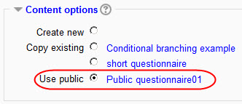
In the Content options section, in the radio buttons list, under Use public, the title of the public questionnaire you created in the other course (PubQuestCourse) will appear (e.g. Public questionnaire01): check its radio button. Then finish editing (click the Save and return to course button).
Note.- For options 4-6 above, an admin may ask individual teachers to create those questionnaires based on a public questionnaire in their own courses, giving them detailed instructions on how to proceed. Unfortunately at the moment there is no way to automatically deploy a public questionnaire to other courses, it has to be done "by hand".
- Student responses will appear in the original questionnaire (e.g. "Public questionnaire01" in course PubQuestCourse), but will not be visible at all in the "local" questionnaire (alias). Teachers will not be able to respond to it or view their students' responses.
IMPORTANT Please note that when you delete a Public questionnaire, you also delete the links to its "dependent" questionnaires in the other courses on your moodle site. If a Public questionnaire is no longer used, the normal procedure is to go to all the other courses that "use" that Public questionnaire and delete them first.

Template questionnaire used in multiple courses
When the responses to your questionnaire should remain accessible in the course in which it resides, but the questionnaire itself will follow a standard format with the same questions, use a template-type of questionnaire. So instead of re-creating the questions for each questionnaire, you can apply the template questionnaire to each one you create.
Here's how you do it:
- Create a course that will simply be a shell for any template questionnaires. Give it whatever title you like e.g. TempQuestCourse. You can hide the course entirely.
- Create your questionnaire in this course. On the "Advanced settings" page, select Template for the questionnaire type.
- Add questions in this template questionnaire.
- Navigate to the course where you want to place an alias of that Template questionnaire.
- Add an activity or resource: Questionnaire. Edit all the various settings. Name it e.g. Questionnaire02.
- 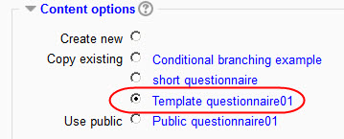
In the Content options section, in the radio buttons list, under Copy existing, the title of the Template questionnaire you created in the other course (TempQuestCourse) will appear (e.g. Template questionnaire01): check its radio button. Then finish editing (click the Save and return to course button).
If you don't want your teachers to view or alter questionnaire responses, just define this in the Define Roles settings for Questionnaires. In Define Roles, you can limit teachers from being able to delete responses from the questionnaire, or be able to submit their own questionnaires or view responses.

Title/Sub-title
Title of the questionnaire, which will appear at the top of every page. By default Title is set to the questionnaire Name, but you can edit it as you like.

Additional Info
Text to be displayed at the top of the first page of the questionnaire. (i.e. instructions, background info, etc.)

Submission Options

Confirmation URL/page
Heading (in bold) and body text for the "Confirmation" page displayed after a user completes this questionnaire. (URL, if present, takes precedence over confirmation text.) If you leave this field empty, a default message will be displayed upon questionnaire completion (Thank you for completing this Questionnaire).

Email
Sends a copy of each submission to the specified address or addresses. You can provide more than one address by separating them with commas. Leave blank for no email backup.

Adding Questions

Editing questions
- On the Questionnaire Editing Questions page is displayed a drop-down list of the question types available and a list of the questions already created for the current questionnaire instance (if any).
- Using the standard Moodle icons you can change the order of the questions in the questionnaire, edit or delete questions.

Common Options

Question Name

Questionnaires not using the Conditional Branching feature
You can optionally enter a Question Name for each question.
If your questionnaire does not use the "Conditional Branching" feature, the Question Name is only used when you export responses to CSV/Excel format. If you never export to CSV, then you needn't worry about Question names. If you plan to regularly export your questionnaire data to CSV, then you have a choice of two options for question naming.

Option 1: significant names
In the Question Name box, enter meaningful, short and different question names for all of the questions within one questionnaire. In the CSV export file, all those question names will be prefixed with the question's actual number (= position) in the quiz. Examples:
question number (position) in the questionnaire | question name entered by teacher | field header in csv export
5 | favorite colors | Q05_favorite colors
6 | why_use_Moodle | Q06_why_use_moodle
7 | user-friendliness  (rate question with 3 possible answers: Moodle, WebCT and Blackboard) | Q07_user-friendliness->Moodle  Q07_user-friendliness->WebCT  Q07_user-friendliness->Blackboard

Option 2: leave the Question Name boxes blank
For each un-named question, CSV export will automatically generate a question name. This is required for table header fields in the CSV and subsequent Excel tables or any statistics package you might be using. The question name generated will be based on the question number in the actual Quiz (excluding Section Text pseudo-questions, of course) e.g. Q01, Q02, ... Q99. For questions with multiple answers, such as rate-type or Likert type questions, a sub-question number will be generated (Q02_1, Q02_2, Q02_3, etc.). This type of "short-name" naming scheme is advisable for exporting your data to a statistics software. Of course, it's up to you to have your own system for remembering which abbreviated question name corresponds to which question in your questionnaire!
question number (position) in the questionnaire | question name entered by teacher | field header in csv export
5 |  | Q05
6 |  | Q06
7 |  | Q07_1  Q07_2  Q07_3
It is quite possible (but maybe not advisable) to mix the two systems, and have within one questionnaire both named and un-named questions.

Conditional Branching Feature

If you need a question to be used as the "parent" of one or more subsequent questions in your questionnaire, then you must name that "parent question". Only those (radio buttons, dropdown list or yes/no) questions with a name will appear in the Parent question dropdown list when adding a new question, as shown on the following screenshots.
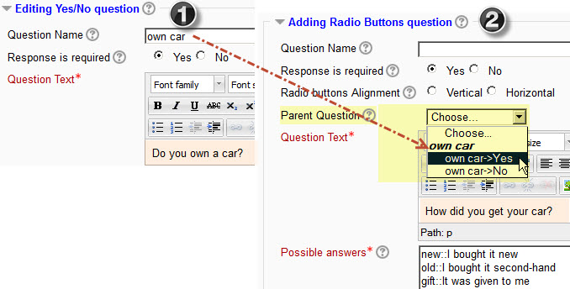
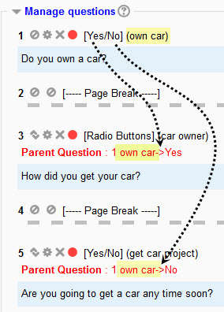
For more information, see Conditional branching.

Response Required
If you select Yes, response to this question will be required, i.e. the respondent will not be able to submit the questionnaire until this question has been answered. If the respondent tries to submit a questionnaire with unanswered required questions (or, in the case of a questionnaire with more than one section, to go to the next page), a warning message will be displayed with a list of all the missing required questions in the questionnaire (or on the actual page).
Default.- No.
Note.- When you create new questions in sequence (one after the other), this parameter is carried over to subsequent questions. E.g. if you create question #1 with Response Required = Yes, then the Response Required parameter will be pre-set to Yes for question #2, etc. You can of course change this parameter at any time.
In the Manage Questions section of the Questions editing page, once a question has been created, you can use the green and red dots to switch its Required state, as a shortcut alternative of editing the question.
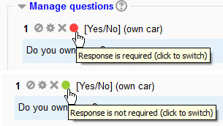

Question Text
Enter your question text in this box. The HTML editor is available, which means that you can display not only formatted text but also images or other media in a questionnaire's questions text.

Question Types
Select the type of question from the drop-down list and click on the Add selected question type button.

---Page Break---
Use this to insert page breaks in longish questionnaires. Note that if a page contains questions with required response the respondent will not be allowed to navigate to the next page unless those required responses have been given.
If your questionnaire uses the Conditional branching feature, then page breaks will be automatically inserted when you add "parent" or "child" questions. Page breaks which are needed to ensure a correct "Conditional branching" flow cannot be moved or deleted. Their Move and Delete icons are disabled.
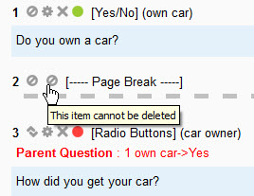

Check Boxes
Check boxes allow the user to select multiple answers from a list of options.
Question editing interface
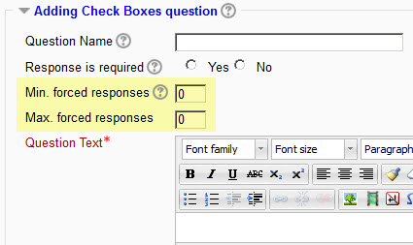

Editing Mode | Questionnaire View
Question text: What are your favorite hobbies?  Possible answers:  Watching TV  Dancing  Computing  !other=Another hobby: | 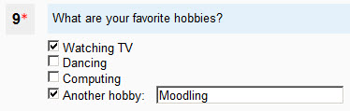
You may enter “!other” on a line to create an optional fill in the blank option. An!other box defaults to using the prompt Other: , (or the equivalent translation for Other in the current language being used). You may change this default prompt by using the format: “!other=prompt text” as shown in the example above.
Notes.-
- At the moment the length of the fill in the blank input text box is set to 25 characters and is not customizable through the online interface.
- You may provide more than one !other fill in the blank option for a Check Boxes question, but this might cause problems so it is not recommended.
- When a respondent answers a Check Boxes question which has been created as Required, and the Min. forced responses and Max. forced responses parameters have been used, then a warning message will be displayed if respondent does not check the required number of boxes.
- Note that, if the !other fill in the blank option has been created, then if it is checked by the respondent, it will count in the total of minimum/maximum required check boxes.
- If a respondent checks a fill in the blank option check box and leaves the text field empty, that box will be unchecked (upon navigating to the next page or upon submitting the questionnaire).
- If a respondent has cheked a fill in the blank option check box and has filled in the text field, and later on changes his mind and unckecks that box, the fill in the blank text field will be automatically emptied (cool, ain't it?).

Date
Use the day/month/year format, e.g. for March 14th, 1945: 14/3/1945
Use this question type if you expect the response to be a correctly formatted date. The format will depend upon the language currently being used by the questionnaire respondent. For example 4/21/2007 (US); 21/4/2007 (UK); 21-4-2007 (France); etc. An example will be displayed in the questionnaire. If an "impossible" or wrongly formatted date is entered, it will either be re-written or reformatted correctly (if possible) or an error message will be displayed to the respondent. In order for dates to be correctly exported to spreadsheets such as Excel, respondent must enter a date in the 1902 to 2037 range. If a date outside this range is expected from respondents, then use the Text Box question type instead. The date question type will accept dates consisting only of a month plus a year (e.g. 12/2008 for december 2008) or only a year (e.g. 2008). However, for spreadsheet processing compatibility, such incomplete dates will be automatically transformed to complete dd/mm/yy dates, e.g. 12/2008 -> 01/12/2008 and 2008 -> 01/01/2008. You may have to explain this pecularity to your questionnaire users beforehand.

Dropdown Box
There is no real advantage to using the Dropdown Box over using the Radio Buttons except perhaps for longish lists of options, to save screen space.

Essay Box

Question editing interface
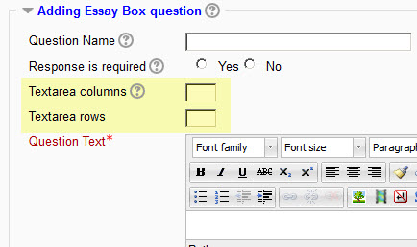

Settings
This question will display a plain text box with x Textarea columns (or area width) and y Textarea rows (number of text lines).
If you leave both x and y to their default 0 value (or if you set it to 0), then moodle's HTML editor will be displayed with standard height and width (if available in the course/user context & user profile).

Label
This is not a question but a (short) text which will be displayed to introduce a series of questions.

Numeric
Use this question type if you expect the response to be a correctly formatted number. By using the Max. digits allowed and Nb of decimal digits parameters you can specify the length and number of decimal places required.

Radio Buttons

Question editing interface
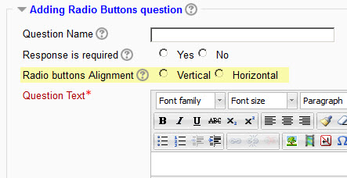

Radio buttons Alignment
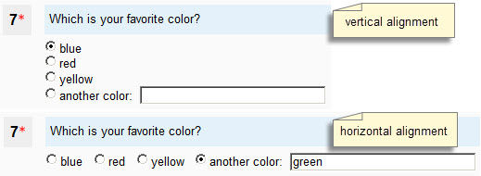

Possible answers
You must fill in one answer per line in the Possible answers box.
Examples:
Editing Mode | Questionnaire View | (optional horizontal display)
1.Possible answers :  Red  Blue  Black | What is your favorite color?  Red  Blue  Black | What is your favorite color?  Red Blue Black
2.Possible answers :  Red  Blue  Black  !other | What is your favorite color?  Red  Blue  Black  Other: | What is your favorite color?  Red Blue Black  Other:
3.Possible answers:  Red  Blue  Black  !other=Another color: | What is your favorite color?  Red  Blue  Black  Another color: | What is your favorite color?  Red Blue Black  Another color:
 | Questionnaire View | Text data export
4.Possible answers:  red::the color of blood  blue::the color of the sky  black::opposite of white | What is your favorite color?  the color of blood  the color of the sky  opposite of white | The "values" red, blue and black will be exported to the columns instead of standard 1, 2 and 3 numbers.  See Download in text format.
You may enter “!other” on a line to create an optional fill in the blank option. An !other box defaults to using the prompt Other:, (or the equivalent translation for Other in the current language being used). You may change this default prompt by using the format: “!other=prompt text” as shown in Example #3 above.
Notes
- At the moment the length of the fill in the blank input text box is set to 25 characters and is not customizable through the online interface.
- It does not make sense to provide more than one !other fill in the blank option for a Radio Buttons question.
- If a respondent checks a fill in the blank option radio button and leaves the text field empty, a warning message will be displayed (upon navigating to the next page or upon submitting the questionnaire).
- If a respondent has checked a fill in the blank option radio button and has filled in the text field, and later on changes his mind and clicks a different radio button in the same question, the fill in the blank text field previously entered will be automatically emptied.
- Example #4 shows a possible "hidden" option, for exporting - in responses - named values as data instead of standard numbers. If you never export your data for studying it in stats packages you won't need this option.

Rate (scale 1..5)

Example:
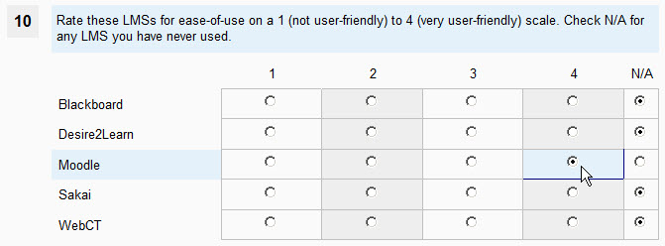

Question editing interface:
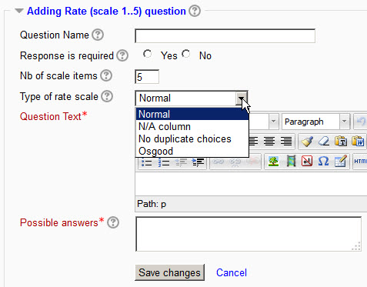

Number of scale items
Nb of scale items is the number of items to be used in your rate scale. You would normally use a value of 3 to 5. Default value: 5.

Type of rate scale
- Normal (default value)
- N/A columns : Choose this if you want an N/A column to be added to the right of your Rate scale items columns.
- No duplicate choices: Choose this if you want to prevent duplicate choices in each degree column.
  - This is useful if you want the respondent to rank a number of items on a 1 to n scale and to force each rank to be unique. Example: order items A, B and C in order of preference will accept: A1, B3 and C2 or A3, B2 and C1, but it will not be possible for the respondent to enter: A1, B1, C2 or A1, B2, C2, etc.
  - Used in conjunction with named degrees, this No duplicate choices option can also be useful if you want the respondent to match items with named degrees, e.g. the colors red, blue, yellow with a set of physiological responses: excitement, tranquillity, concentration where one color can only match one physiological response.
- Osgood: Choose this to create a question of the Osgood's semantic differential type. This parameter must be used in conjunction with named degrees.

Possible answers
Examples.
Editing Mode | Questionnaire View
Ex. 1 Rate (single line)  Possible answers -> Enter a blank space or a short "label". Settings:  Nb of scale items = 5 (5 columns numbered 1...5);Type of rate scale = Normal (N/A column not needed here). | 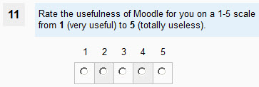
Ex. 2 Rate (several lines)
Possible answers.
Blackboard
Desire2Learn
Moodle
Sakai
WebCT
Settings:
Nb of scale items = 4 (4 columns numbered 1...4)
Type of rate scale = N/A column
Ex. 2a Rate ("ordering")  This option makes it impossible to click more than one radio button per column; it is thus equivalent to an "ordering" question type.  Settings:  Nb of scale items = 3 (3 columns numbered 1...3)  Type of rate scale = No duplicate choices | 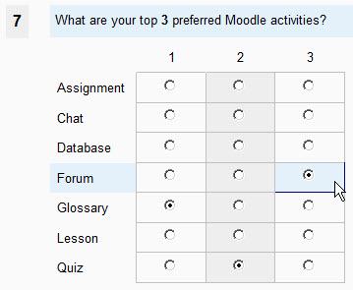
Ex. 3 Rate with named degrees  Possible answers.  4=Very easy to use  3=Easy to use  2=Somewhat difficult to use  1=Difficult to use  Formatting Your Course  Laying out Your Course  Number of Clicks to Access Needed Content  Adding Content  Ability to Add/Change Themes/Appearance  Overall Navigation of Moodle  Settings:  Nb of scale items = 4 (4 named columns)  Type of rate scale = Normal (N/A column not needed here) | 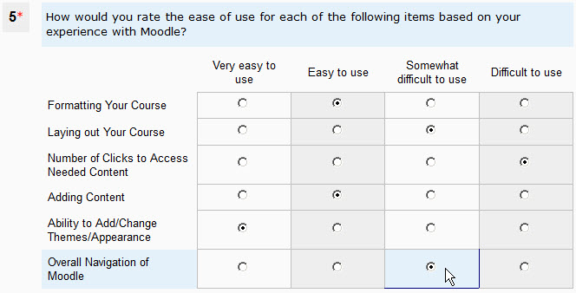
Ex. 3b Rate with named degrees  Possible answers.  4=Very easy to use  3=Easy to use  2=Somewhat difficult to use  1=Difficult to use  formatting::Formatting Your Course  layout::Laying out Your Course  clicks::Number of Clicks to Access Needed Content  addcontent::Adding Content  appearance::Ability to Add/Change Themes/Appearance  navigation::Overall Navigation of Moodle | If the choice options text is fairly long, you may use shorter "labels" immediately followed by two colons (::). The labels "formatting", "layout", "clicks" etc. will be saved to the columns headings in the Download as text format operation, instead of the longer labels which will be displayed to the questionnaire respondent.  Please note that in former versions of Questionnaire the separator between "short label" and "options text" used to be the equal sign (=). In Questionnaire 2.5 and later, please use two colons (::) as a separator.
Ex. 4 Osgood's Semantic differential '  Possible answers.  1=--  2=-  3=±  4=+  5=++  weak|strong  cold|warm  cowardly|brave  Settings:  Nb of scale items = 5 (5 named columns)  Type of rate scale = Osgood  Note.- To separate the pairs of words you must use a pipe character | | 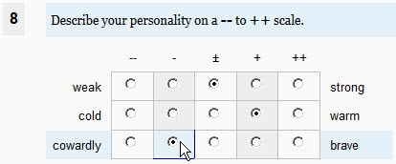
Notes.- named degrees
For this question type you have two display options. The default option displays the Likert scale degrees as numbers (1...5). If you prefer to have named degrees instead of numbers, you'll have to enter those names in the Possible answers list (see Example 3 above). On each line of "possible answers" enter the degree number, immediately followed by the equal sign = immediately followed by the name you want to give to that degree.
Actually, the number preceding each named degree is only there to remind you of its position on the horizontal scale; it is not used by the programme, and you might as well use, eg. 0=Almost Never; 0=Seldom; 0=Sometimes; etc. But you must begin with a number immediately followed by the equal sign = .
If the number of named degrees in the possible answers list is different from the number determined by the value you entered in the Nb of scale items field, this will be automatically adjusted when you save the question. If you decide to use named degrees for your Likert scale, it is recommended (but not obligatory) to start your list of possible answers with the named degrees, and then to enter the various items to be scaled.
Example #3b shows a possible "hidden" option, for exporting - in responses - shorter label instead of the longer text values. If you never export your data for studying it in stats packages you won't need this option. Please note that the example is provided here for the Rate with named degrees question sub-type but it works for all Rate question sub-types except Osgood which requires short left and right options anyway.

Text Box
For the Text Box question type, enter the Input Box length and the Maximum text length of text to be entered by respondent.
Default values are 20 characters for the Input Box width and 25 characters for the maximum length of text entered.

Yes/No

Manage questions
In the Manage questions section of the Edit Questions page, you can conduct a number of operations on a Questionnaire's questions. Normally you should never add questions or delete questions in a questionnaire that is live in a moodle course, and which some students may have already responded to.
You can Move a question to a different position in the Questionnaire. If your questionnaire contains some "conditional branching" questions, you may not be able to move some of the parent or child questions to some positions which would ruin the branching.
You can Edit a question, but again, be extra careful when editing questions once students have started to complete a questionnaire.
If you try to Delete a child or parent question (in a Conditional branching questionnaire), you will be warned of the possible consequences of those deletions.
By clicking on the Green or Red dots, you can switch the "Response required" status of questions.
Please note that the numbers in front of each question in this interface are not the question numbers that will be displayed when answering the questionnaire. Here, these numbers indicate the question's position, and even non-real questions such as Labels and Page Breaks have a position number.

Conditional Branching

Definition
Conditional branching (or Skip logic) is a feature that changes what question or page a respondent sees next based on how they answer the current question. Conditional branching creates a custom path through the survey that varies based on a respondent’s answers.

Organization
In the Questionnaire plugin, the Conditional branching path is organized through pages, containing one or more "child" questions depending on a "parent" question.

Settings
If you want to use the Conditional branching feature in a Questionnaire, when you create or edit the questionnaire, in the Response options section of the settings, you must set the Allow branching questions option to Yes. Please note that this option is set to No by default.

Example

The flow we want to obtain
- Page 1
  - Question 1 Do you own a car? Yes/No.
    - Answer Yes -> go to page 2
    - Answer No -> go to page 5 (i.e. skip over irrelevant questions in pages 2 through 4)
- Page 2
  - Question 2: What is the color of your car?
  - Question 3: Did you buy it new or second-hand?
    - Answer new -> go to page 3
    - Answer second-hand -> go to page 4
- Page 3
  - Question 4: Did you pay your new car cash or did you get a bank loan?
- Page 4
  - Question 5: Did you buy your second-hand car from a garage or directly from its previous owner?
- Page 5
  - Question 6: Do you sometimes use public transport to go to work?

Procedure to obtain that flow
- Create Q1 as a Yes/No question.
  - Question Name: own car. Note that you must give your question a name, as this name will be used later on in the Questionnaire to build the list of available Parent questions. Please keep this name as short as possible.
  - Response Required: Yes. Since you plan to use question Q1 as a Parent question, it would not make sense to set it as non-required.
  - Question Text: Do you own a car?
  - Save Q1. No Page break will be inserted at this stage because you have not yet used a Parent question to create one or more Child questions.
- Create Q2 as a Text Box question type
  - Question Name: optional
  - Response Required: Yes or No (depending on what you want to do with that question's answers later on).
  - Parent Question : own car->Yes. The Parent question (Q1) option offers 2 choices, since it is a Yes/No question.
  - Question Text: What is the colour of your car?
  - Save Q2. Upon saving Child question Q2 you notice that a Page break has been automatically inserted between the Parent question Q1 and its Child question Q2.
- Create Q3 as a Radio Buttons (or Dropdown Box) question type
  - Question Name: car status
  - Response Required: Yes. We are giving question Q3 a name and setting it as Required because we plan to use it as a Parent question.
  - Parent Question: own car->Yes
  - Question Text: Did you buy it new or second-hand?
  - Possible answers:
    - new::I bought it new
    - used::I bought it second-hand.
  - Please note that in the Possible answers field we are using the "short label" feature. You should use this feature if the full text of your Possible answers choices is fairly long.
  - Save Q3. Upon saving Child question Q3 you notice that no Page break has been inserted. This is because both Q2 and Q3 are Child questions of the same Parent question Q1 and thus will be displayed on the same page of the questionnaire.
- Create Q4 as a Radio Buttons question type
  - Question Name: optional
  - Response Required: Yes or No
  - Parent Question: car status->new

  - Please note that the list of potential Parent question choices displays the "short label" that we entered for the Possible answers in Q3, instead of the full text.

  - Question Text: How did you pay for your new car?
  - Possible answers:
    - I paid cash
    - I got a bank loan
  - Save Q4. Upon saving Child question Q4 you notice that a Page break has been automatically inserted between Parent question Q3 and its Child question Q4.
- Create Q5 as a Radio Buttons question type
  - Question Name: optional
  - Response Required: Yes or No
  - Parent Question: car status->used
  - Question Text: Where did you buy your second-hand car?
  - Possible answers:
    - I bought it from a garage
    - I bought it directly from its previous owner
  - Save Q5. Upon saving Child question Q5 you notice that a Page break has been automatically inserted between Child question Q4 and Child question Q5 because these two question do not have the same Parent question.
- Create Q6 as YES/NO question type.
  - Question Name: optional
  - Response Required: Yes or No
  - Parent Question: None.
Question 6 is not dependent on any of the previous questions, and it will be displayed to the questionnaire respondent regardless of their previous answers.
  - Question Text: Do you sometimes use public transport to go to work?
  - Save Q6. Upon saving question Q6 you notice that a Page break has been automatically inserted between Child question Q5 and question Q6.
Now continue creating questions normally, until you want to use Conditional branching again.
Here is what your Manage questions section will look like after you have created those first 6 questions.
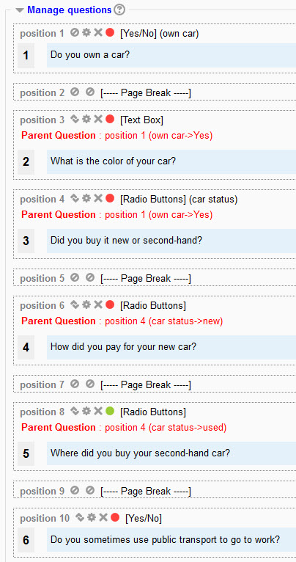

Operations on Conditional branching questions

Move
By using the standard Moodle "Move" icon you can move your questionnaire questions to different positions. However, due to the special nature of the questionnaire flow when using the Conditional branching feature, there are restrictions on the new positions that you can move our questions to.
- You cannot move a Parent question below any of its Child questions.
- You cannot move a Child question above its Parent question.
- You cannot remove those Page breaks which are needed to ensure a correct flow of dependent questions.
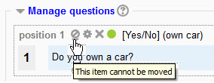
Those restrictions will show on the Manage questions screen where the Move icon is replaced with a "Forbidden" (Moodle "block") icon. They will also operate when you are in "Move question" mode, where the Move to here icon/placeholder will not be displayed in the "forbidden" positions.

Edit
Using the standard Moodle "Edit" icon you may edit any question. However, for those questions which have both a Parent question and one or more Child questions, you cannot change their Parent question & Choice, as that might ruin the consequent flow. The only way to change their Parent is to edit their Child question(s) first.
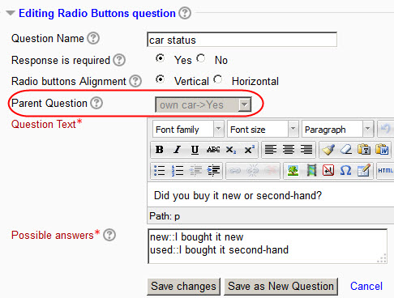

Delete
You cannot Delete those Page breaks which have been automatically inserted when adding Child questions.
If you try to Delete a Parent question, you will get a warning with the list of its Child questions. If you answer Yes to the warning, the Parent question will be deleted, together with all its Child (and Grand-Child questions).
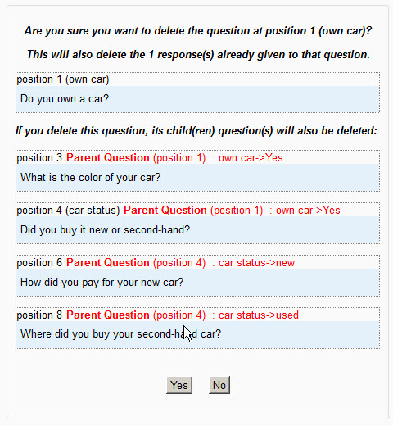

Setting as Required/Not required
As said above, you would normally set all potential Parent questions as Required. However, there might be cases where you want to leave the respondent the choice to respond or not. If you set a question as Not required, then the usual "No answer" button will be displayed (for Yes/No and Radio Buttons questions). If the respondent does not answer a Parent question, all of its Child questions will be skipped over.

Previewing Questionnaire
The Previewing Questionnaire page is useful for a Questionnaire creator to test it out before making it available in a course. In the case of a Conditional branching questionnaire, the Preview is especially useful as it will mimic the flow that a respondent will see, by selecting the various choices offered by the Parent questions.
When a Conditional branching questionnaire is first displayed on the Preview page, only those pages containing "top" parent questions are displayed, as well as pages containing questions that do not have a Parent question.
When a choice id made in the Parent questions, the Child question(s) corresponding to that choice is/are displayed.
The following screnshots illustrate the various possible sequences that can be displayed. In this example, we have set Question 3 as Non-required.
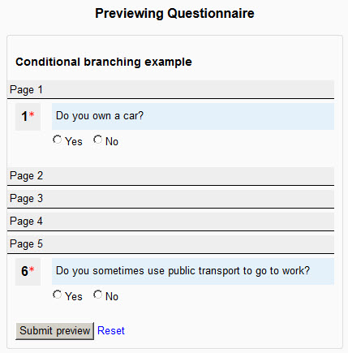
The only 2 questions displayed are those with no Parent: Q1 and Q6.
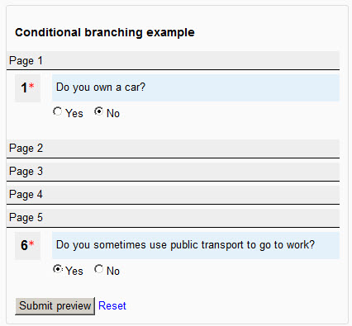
Upon clicking on Q1 'No', nothing changes in the display, because in our questionnaire we do not have any Child question dependent on that choice.
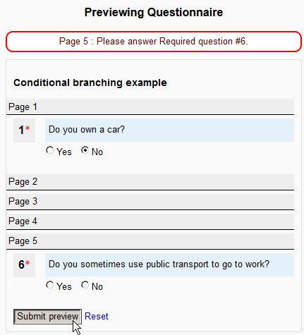
It is possible for a teacher previewing a questionnaire to "Submit the preview". This will mimic the behaviour of the real Submit questionnaire process: any required question that has not been responded to or any response that does not conform to the question's conditions will be marked with a Warning.
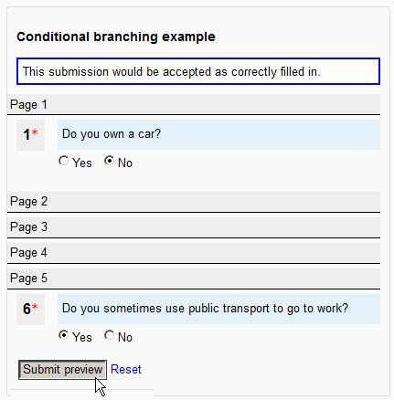
If all the required questions have been correctly filled in, then upon submitting the preview, a "correct" message will be displayed.
- To simulate a new questionnaire flow, you can either click the Preview link in your course's navigation bar, or the Preview link in the Questionnaire Administration block or the Reset link at the bottom of the Preview window.
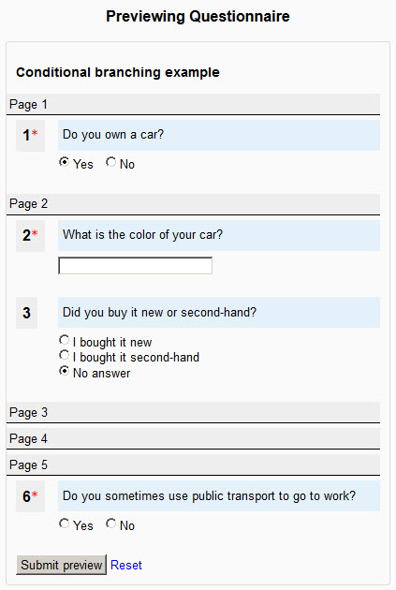
Upon clicking the Yes radio button in answer to Q1, questions Q2 and Q3 on Page 2, which depend on that Q1 Yes choice are automatically displayed. In "Answer the questions" mode, the respondent would be taken to Page 2 of the questionnaire. Now, if we click on the I bought it new radio button of Q3, Q4 on Page 3 will be displayed, etc.

Individual Responses Report
Branching questionnaire reports display the same as non-Branching ones. The only notable difference is with the Individual Responses Report, where it is possible to view the particular path that a respondent took through the various conditional questions. Here are 2 examples.
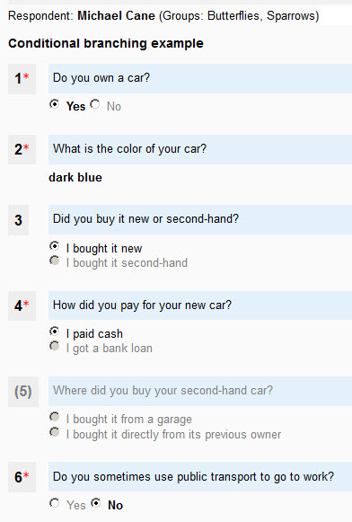
Respondent "Michael Cane" said he owns a red car, bought it new and paid cash for it. He was not presented with Q5, which is displayed between parentheses and greyed out.
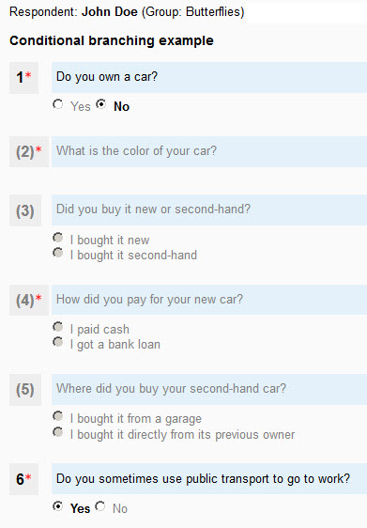
Respondent "John Doe" said he does not own a car. He was not presented with any of the dependent questions Q2 through Q5.

Viewing Questionnaire Responses

All responses
On the Questionnaire Report page, users with the necessary permissions can view a statistical Summary of all the responses given to a Questionnaire instance so far.

Responses display by question type

Numeric
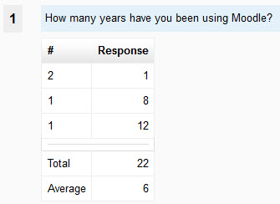
Column 1 displays the number of similar responses. Column 2 displays the responses given. The Total and Average cells are self-explanatory.

Yes/No
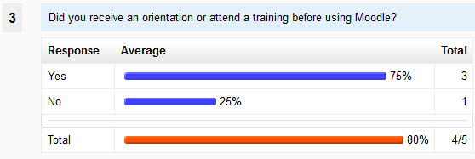
This screenshot shows that out of 5 respondents who responded to this questionnaire, one did not answer this Yes/No question (which was not set as Required). 3 respondents answered Yes (75%) and 1 answered No (25%). Please note that the percentages are calculated on the actual responses, not the total of those who submitted the questionnaire.

Radio buttons
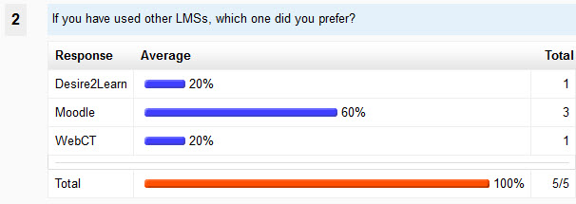
This screenshot shows that 5 our 5 respondents who submitted this questionnaire answered that question (which was Required).

Check boxes
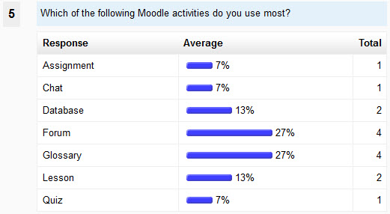
This screenshot shows for instance that the Forum and Glossary activities are favored by 4 respondents (out of 5 who responded), accounting for 27% of the choices each.

Rate question
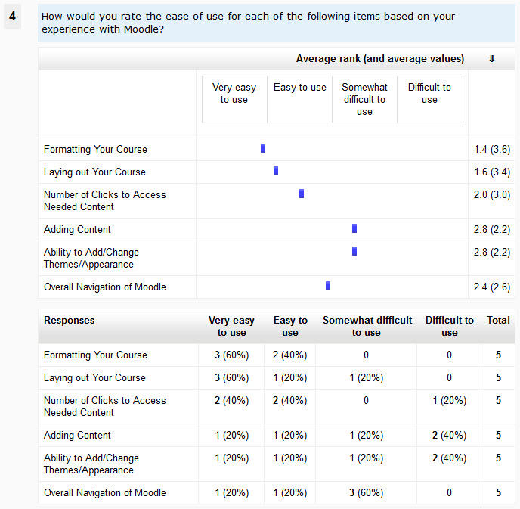
The statistics for Rate questions display 2 tables.
The top table displays the Average rank for each feature. In this screenshot, the "Formatting your course" feature of Moodle was rated on average 1.4 on the 1 to 4 scale of difficulty, i.e. that feature was rated as between "Very..." and "Easy..." to use. When creating that Rate question, the following values were entered for each "possible answer":
- 4=Very easy to use
- 3=Easy to use
- 2=Somewhat difficult to use
- 1=Difficult to use
That is to say that the highest "mark" or "value" was given to the easiest choice. So, the average values (between parentheses) immediately after the average ranks are here the inverse of the average ranks.
The bottom table displays for each feature the number and percentage of respondents who selected each choice. For instance, for the "Formatting your course" feature, 3 respondents (60% of respondents to that question) selected the "Very easy to use" choice, and 2 respondents (40% of respondents to that question) selected the "Easy to use" choice. Nobody selected the "Difficult" choices for that feature.

Essay question
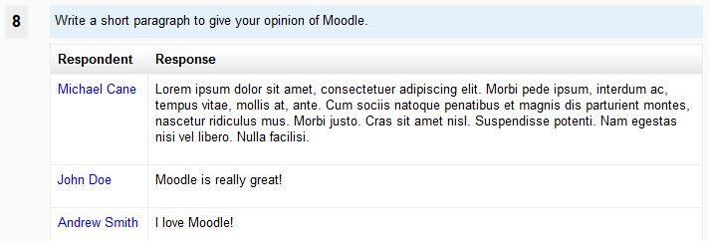
If the questionnaire is set to "full name" (i.e. non anonymous), the respondent's name will be displayed next to their Essay response. Click on the respondent's name to view their full submission.

Group filtering
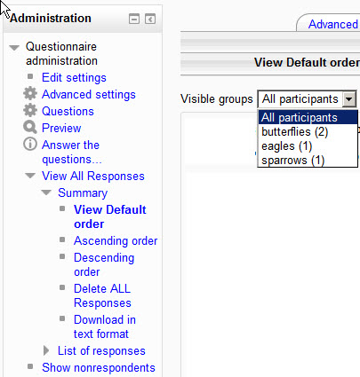
If the questionnaire is set to Group Mode: Visible groups, or is set to Separate groups and the current user has the moodle/site:accessallgroups capability (in the current context), and groups have been defined in the current course, then the user has access to a dropdown list of groups. This dropdown list enables the user to "filter" the questionnaire responses by groups. If the setting is Group Mode: Separate groups, then users who do not have the moodle/site:accessallgroups capability (usually students, or non-editing teachers, etc.) will only be able to view the responses of the group(s) they belong to.
- All participants includes responses from all the people who answered the questionnaire, including people not belonging to any group.
- Members of: All groups includes responses from people who belong to any group.
- And People not in a group is self-explanatory.;
Important.- After you have used the dropdown list to select a "set of people" for displaying their responses, the "filter" remains active for the following operations: Download in text format, Delete ALL Responses and View by Response. For example, if you selected to display All Responses for group "Sparrows" and then click on the Delete ALL Responses tab link, a confirmation message will ask you to confirm that you want to delete all responses for members of group "Sparrows" and only responses of those participants.
Note.- If a participant belongs to more than one group, then deleting all the responses for one of the Groups he belongs to will of course delete his responses from all the other groups he belongs to.

List of responses

View Individual Responses
If the questionnaire Respondent Type was set as “fullname”, users with the necessary permissions (usually only teachers or tutors) can view each response individually. On the List of responses page, each respondent's name is displayed, in alphabetical order of the family name. Upon mouseover, a tooltip displays the submission time-stamp. This is especially useful in case the questionnaire is set to answer more than once and some students have submitted more than one response. Click on a respondent's name to display their submission to the questionnaire.

Individual Responses Navigation
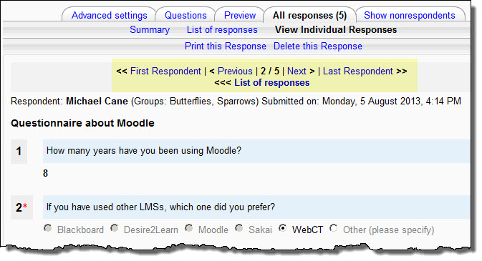
When you are viewing a respondent's individual response, use the navigation bar at the top to go to the Previous (in alphabetical order) or Next response. You can go back to the List of responses page at any time.

Print this Response
Opens printer-friendly window with current Response.

Delete this Response
Deletes current response.

Order Responses
When displaying All Responses you can order the choices by number of responses (the Average column) for the following 4 types of questions.
- single choices radio button
- single choices drop-down list
- multiple choices (check boxes)
- rate questions (including Likert scales).
When you arrive on the All Responses page, by default all responses are ordered in the order that the questionnaire creator entered the question choices. You can choose to order them by ascending or descending order.

Delete All Responses
Deletes all responses in current questionnaire instance. Can be used to “reset” a questionnaire if you no longer need the current data.

Download in text format
This feature enables you to save all the responses of a questionnaire to a text file (CSV). This file can then be imported into a spreadsheet (e.g. MS Excel or Open Office Calc) or a statistical package for further processing the data.

Options for text download
On the Download in text format page you have a set of 2 options which only concern the output of the radio buttons/single answer question type. Here is how these options work.
Question text: What is your favorite color? Choice: blue, green, red.

selected color | blue | green | red
Include choice codes | 1 | 2 | 3
Include choice text | blue | green | red
Include choice codes + Include choice text | 1 : blue | 2 : green | 3 : red
No Include box ticked = same as include choice text box ticked | blue | green | red
Note that these output options are over-ridden in case you used the "hidden" option when you created your radio button questions, i.e. the named values will be exported as data.

Possible answers:  Red=the color of blood  Blue=the color of the sky  Black=opposite of white | What is your favorite color?  the color of blood  the color of the sky  opposite of white | Irrespective of the Include choice codes/text options selected on the Download in text format page, this will output the values Red, Blue or Black to the CSV file.

The CSV file (how to use it)
The text format available here is of the so-called CSV (comma separated values) type. However, for more universal use, the tab (tabulation) separator is used, rather than the comma or semi-colon.
When you click on the Download in text format button, a window opens, asking you whether you'd like to save the data file or open it. Select save. The data file is named after the name of the current quiz, however you can save it under a different name. The proposed data file extension is *.txt, but you can rename it. Note that you must rename it with a *.csv extension for import into Open Office Calc.
Then go to your external software, and open the file into it. The following operations depend on the software you are using and on a number of other parameters. If you are using a non-ascii language interface in Moodle or you are using the English language but some of your questionnaire questions (or responses) have non-ascii characters in them, then Excel (or Open Office Calc) might be able to automatically detect that your file is UTF-8 encoded, and decode it accordingly. Please note that if most of your data file is using standard ascii characters and only a very small number of non-ascii characters are present, the automatic detection will not work, and you will have to manually select the UTF-8 encoding in the list provided by your software.
At the top of the "table" imported into e.g. Excel, the first line contains the names of all the question fields. This is followed by one line per response. The first 7 fields are as follows (in the English version):

Response | Submitted on: | Institution | Department | Course | Group | ID | Full name | Username
The submitted_date field contains the date (and time, i.e. hour minutes seconds) when the response was submitted by respondent. For example: 15/09/2007 15:57. Normally you should be able to use Excel cell formatting to display such dates at will, in your own language formatting conventions, including the seconds, and if you wish full day or months names, while retaining the sorting facility.
If the questionnaire was set as "anonymous responses", the ID and Username will be empty and the Full name field will display "Anonymous".

Your Responses
On the Questionnaire Report page, users with the necessary permissions can view their own responses on the page entitled “Your results”. Usually students will be allowed to view their own responses.
If the questionnaire's settings allow more than one response and more than one response have been entered by the current user, then all of the features of the “View All responses” explained above apply.
However, it is not possible to delete individual responses in this “Your responses” view. And the Download as text format is not available to users with the student role.

All your responses
This provides a view of all of a respondent's responses, on successive dates. This feature may be useful if a questionnaire is used as a kind of portfolio.

Show Non-Respondents

This feature allows the teacher to see students who have not yet responded. A reminder message can be sent to individuals or to everyone that hasn’t submitted responses.
The list of "non-respondents" can be filtered by Group (if Groups are enabled for this course and activity).
If the questionnaire's Save/Resume answers is set to Yes, then the list shows those students who have started but not yet submitted their questionnaire responses.
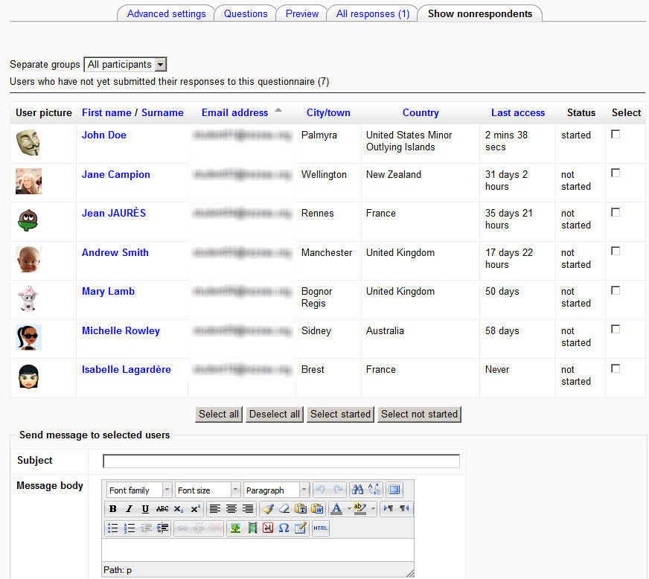

Personality Test

Overview

Definition
In the Moodle Questionnaire add-on, the "personality test" feature enables a questionnaire creator to attribute different "values" to the answers to certain types of questions. Those values can be added into scores - globally or in several "sections" - and relevant feedback messages based on those scores can be displayed to the respondent.
Given the particular nature of the "personality test" feature, great care should be exercised when using it in questionnaires.

Organization
The following question types can be used with the "personality test" feature: Radio buttons, Dropdown Box, Rate and Yes/No. In order for the answers to those questions to be "scored", they must have a question name, must be required and each of their choices must have a value. For the Yes/No question, the default values are 1 for a Yes answer and 0 for a No.

Settings
See the examples below.

Global Feedback example
Adapted from www.personalitytest.net

Questions
- Create Q1 as a Radio Buttons (or Dropdown Box) question type
  - Question Name: feel your best
  - Response Required: Yes. We are giving question Q1 a name and setting it as Required because we plan to use it in the Personality test feedback.
  - Question Text: When do you feel your best?
  - Possible answers:
    - 2=In the morning
    - 4=During the afternoon and early evening
    - 6=Late at night
Each possible answer choice begins with a value immediately followed by the equal sign (=) immediately followed by the choice words(*). The values attributed to the various choices must be carefully considered in order to obtain a coherent "score" when they are added up in the feedback score calculation. Here we are using the values as given in the "personality fun test" of our example.
(*) No space before nor after the equal sign (=).
Continue to create all 10 questions in the sample questionnaire.

Advanced settings
Now go to the questionnaire's Advanced settings page.

Additional Info
As usual you may use the Additional Info field to enter instructions for the respondents.

Feedback options
Now that your questionnaire contains a number of questions which fill the requirements mentioned above for using the Personality test feature, the Feedback options section is available. In the Feedback options dropdown box, select the first option available, i.e. Global Feedback. You may use the Feedback notes field to enter text which will be displayed to your repondents at the end of their "Feedback report", e.g. external link to more information on the topic, etc. Now click the Save settings and edit Feedback Sections button.

Editing Questionnaire Feedback Sections
On this page is displayed the full list of the questions available for the Feedback report. Since we have selected the Global feedback option, all those questions have been default-set in Section 1, the only section available here. Each question is displayed, and the "value" of each choice is displayed, to help you check their coherence. Normally, you have nothing to change on that page. However you might want to remove one or several questions from the list by clicking the 0 radio button instead of the (Section) 1 button. Now click on the Save Sections settings and edit Feedback Messages button.

Editing Questionnaire Feedback Messages

Global Feedback heading
- This begins with a list of the names of all the questions that are used in this Global Feedback section.
- The Label text box should be kept as short as possible. It will be displayed in the Feedback report and - when the Chart feature is available in a later version of Questionnaire - will be used in the Charts.
- In the Heading field you may type a brief heading text. You may use 2 variables in this heading, $scorepercent and $oppositescorepercent. One example is: "You scored $scorepercent in this questionnaire."

Global Feedback messages
This works exactly the same as the Moodle Quiz Score boundary system. Here are a few examples, still taken from our sample Personality "Fun" test.
- Feedback Score boundary
  - 100%
  - Feedback : Others see you as someone they should "handle with care" You're seen as vain, self-centered, and who is extremely dominant. Others may admire you, wishing they could be more like you, but don't always trust you, hesitating to become too deeply involved with you.
- Feedback Score boundary
  - 94%
  - Feedback : Others see you as an exciting, highly volatile, rather impulsive personality; a natural leader, who's quick to make decisions, though not always the right ones. [etc.]
- Feedback Score boundary
  - 85%
This starts with 3 default boundaries and associated messages, but you may add more boundaries if needed.
When finished, click the Save settings button.

Report
This is how the Feedback report will look like to a respondent after taking our sample questionnaire.
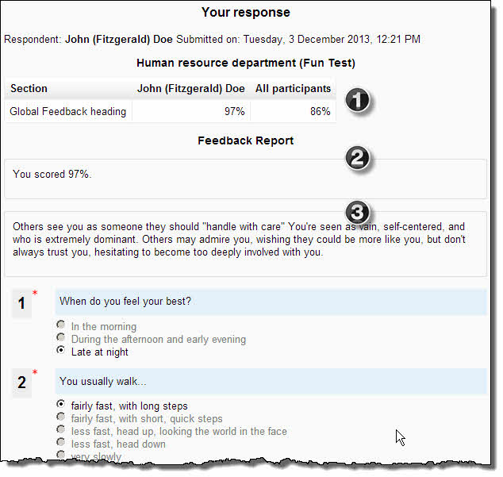
- This table shows the global score for respondent plus, if any, the average global score for all participants. If the questionnaire is set to "separate groups", this box may show the average global score for the group that the actual respondent belongs to.
- In the first box of the Feedback Report we see the Heading text, which may include the value of the $scorepercent variable.
- In the second box we see the "personalized" feedback message, relevant to the Feedback score boundaries that the actual respondent's score sits in.
On the View all Responses page, the Feedback report heading will be displayed, together with the average Global score for All participants. If the questionnaire is set to "visible" or "separate groups", the average global score for the current group will be displayed.
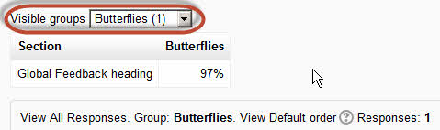

Several sections Feedback example
A simplistic "health habits" questionnaire.

Questions
- Create Q1 as a Rate question type
  - Question Name: sports
  - Response Required: Yes.
  - Question Text: How often do you practise these sports?
  - Possible answers:
    - 0=never
    - 1=once a month
    - 2=every week
    - 3=every day
    - cycling
    - running
    - swimming
    - walking
- Create Q2 as a yes/no question type
  - Question Name: fruit and vegetables
  - Response Required: Yes.
  - Question Text: Do you regularly eat fresh fruit and vegetables?
- Create Q3 as a Radio buttons question type
  - Question Name: smoking
  - Response Required: Yes.
  - Question Text: How often do you smoke?
  - Possible answers:
    - 3=never
    - 2=less than one packet per month
    - 1=one packet per week
    - 0=one packet per day
- Create Q4 as a Radio buttons question type
  - Question Name: drinking
  - Response Required: Yes.
  - Question Text: How often do you drink alcohol?
  - Possible answers:
    - 3=never
    - 2=less than one glass per month
    - 1=one glass per week
    - 0=one glass per day

Advanced settings
Now go to the questionnaire's Advanced settings page.

Additional Info
As usual you may use the Additional Info field to enter instructions for the respondents.

Feedback options
Now that your questionnaire contains a number of questions which fill the requirements mentioned above for using the Personality test feature, the Feedback options section is available. In the Feedback options dropdown box, select 2 Feedback sections. You may use the Feedback notes field to enter text which will be displayed to your repondents at the end of their "Feedback report", e.g. external link to more information on the topic, etc.
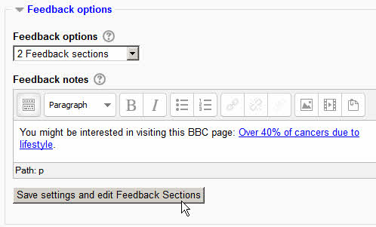
Now click the Save settings and edit Feedback Sections button.

Editing Questionnaire Feedback Sections
On this page is displayed the full list of the questions available for the Feedback report. Each question is displayed, and the "value" of each choice is displayed, to help you check their coherence. By default, the questions are not set into any Feedback Section (all radio buttons are set at 0). You now have to set each question into one of the 2 Sections you decided to display in your questionnaire's Feedback Report. At this stage, those 2 Feedback Sections have not yet been named, so you really have to be careful and make a mental note of "which is which". Suppose you want Section 1 to be related to your respondents' practise of sport, you would put question 1 into section 1 (click radio button 1 for that question). Now suppose you want your second section to be related to "healthy attitude" towards food, drinking and smoking; click all the remaining radio buttons "2" for questions 2, 3 and 4.
Suppose you get it wrong and you mistakenly put all of your questions in Section 1. Upon clicking on the "Save" button, this error message would be displayed: You must select at least ONE question per section! Section(s) not selected: 2
Now click on the Save Sections settings and edit Feedback Messages button.

Editing Questionnaire Feedback Messages

Feedback heading for section 1/2
You will now get a screen very similar to the one you get for Global Feedback messages (as in our previous example). But you will get several screens, one per section.
- Questions in this section:
  - sports
- Label: Physical activity
- Heading: Your "physical activity" score is $scorepercent.

Feedback messages for section 1/2
This works exactly the same as the Moodle Quiz Score boundary system. Here are a few examples, taken from our sample "Healthy habits" questionnaire.
- Feedback Score boundary
  - 100%
  - Feedback: You must be very fit. Congratulations!
- Feedback Score boundary
  - 66%
  - Feedback: Your physical activity is only average. Come on!
- Feedback Score boundary
  - 33%
  - Feedback: You seem to be a real couch potato. Make an effort!
When finished, click the Next section (2/2) button.

Feedback heading for section 2/2
- Questions in this section:
  - fruit and vegetables
  - smoking
  - drinking
- Label: Healthy habits
- Heading: Your "healthy habits" score is $scorepercent.

Feedback messages for section 2/2
This works exactly the same as the Moodle Quiz Score boundary system. Here are a few examples, taken from our sample "Healthy habits" questionnaire.
- Feedback Score boundary
  - 100%
  - Feedback: You seem to have quite healthy habits. Continue!
- Feedback Score boundary
  - 66%
  - Feedback: You seem to have not very healthy habits. Make an effort to cut down on drinking and smoking.
- Feedback Score boundary
  - 33%
  - Feedback: You seem to have not terribly healthy habits. You must make a serious effort.
When finished, click the Save settings button.

Report
This is how the Feedback report will look like to a respondent after taking our sample questionnaire.
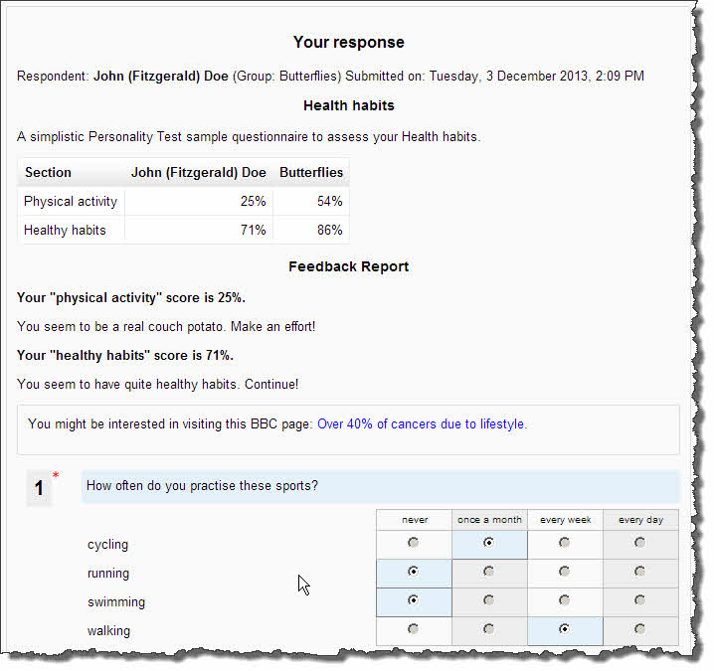
This report is similar to the Global Feedback report in our previous example, except that now the score is separated into 2 sections.

Bipolar results
Some "personality tests" aim at detecting a bipolar characteristic in respondents' character. For example, whether an individual's profile is rather visual or auditory, global or analytic, extrovert or introvert etc.
In such cases, you can enter the section labels as a set of 2 opposed (bipolar) concepts, separated by a pipe character.
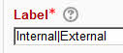
In a questionnaire based on the Locus of Control theory, this "bipolar" heading will give the following kind of report:
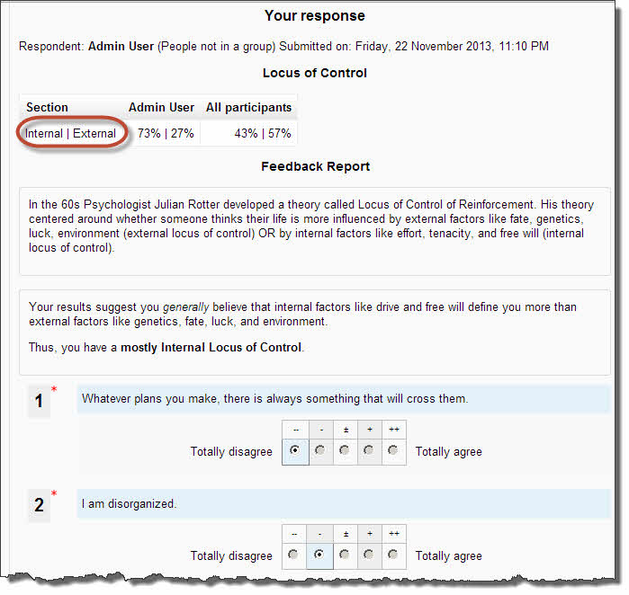

Chart display

Chart types
Navigate to the Advanced settings page and click the Feedback options button.
You can choose to display or not the table of scores in the Feedback report.
The Chart type drop down list that is available is dependent on the number of feedback sections in your questionnaire.
- Global Feedback (i.e. one section only): Bipolar bars or Vertical Progress bar.
- 2 Sections: Bipolar bars or Horizontal bars or Rose.
- More than 2 sections: Bipolar bars or Horizontal bars or Radar or Rose.
Your choice of Chart type depends on the type of questions in your questionnaire. It's up to you to find out the most suitable Chart type. The Bipolar bars type is only suited when your feedback sections include Bipolar_results (see above).
The selected Chart will be displayed on the All Responses page. It will be constructed with all participants' results or, if the questionnaire is set to Visible Groups, with the results of the currently selected group.
On an Individual Responses page, the current user's current results Chart will be displayed, and also the All participants (or current group) results Chart.
Some samples illustrating the complete Chart types that can be used are displayed below.

Vertical Progress bar
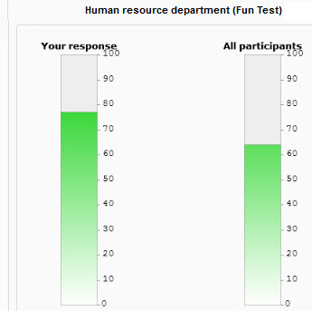
Bipolar bars
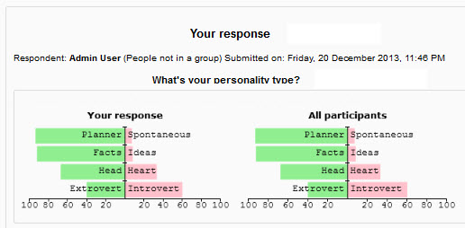

Horizontal bars
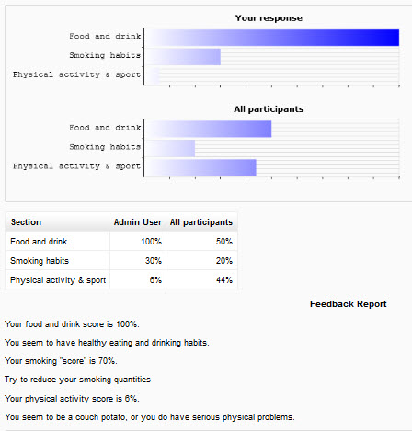

Radar
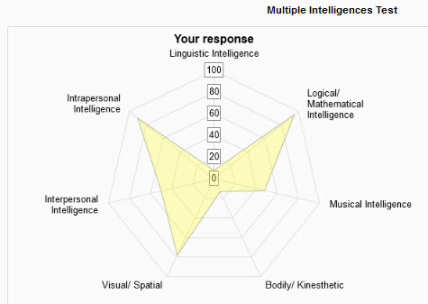
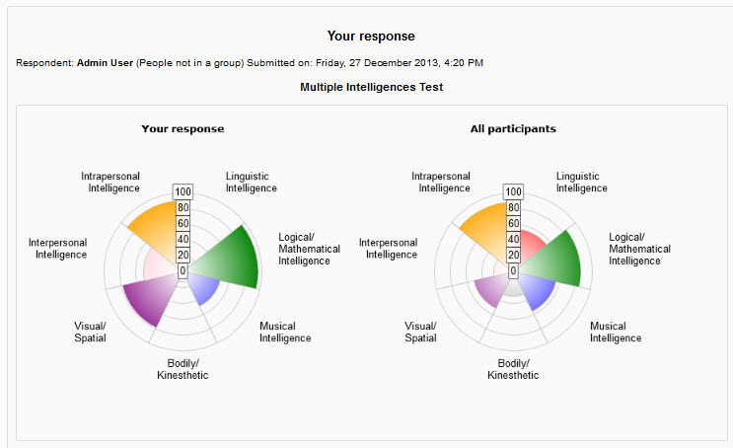
Rose
Confused?
If you are still experiencing issues with Questionnaire, feel free to contact either Bill Kopf or Mandy Roberts.

Bill Kopf
806-720-7355
Bill.kopf@lcu.edu

Mandy Roberts
806-720-7356
Mandy.roberts@lcu.edu

