**Creating a Yellowdig Forum in Moodle 3.3**

Yellowdig in Moodle 3.3 7/11/18



**Yellowdig Forums**

|  |  |
| --- | --- |
| **Simple Just Getting Started Yellowdig Posts** | |
| **Example 1** | **Example 2** |
|  |  |

Yellowdig can be as simple or as AMAZING as you would like !

**V**

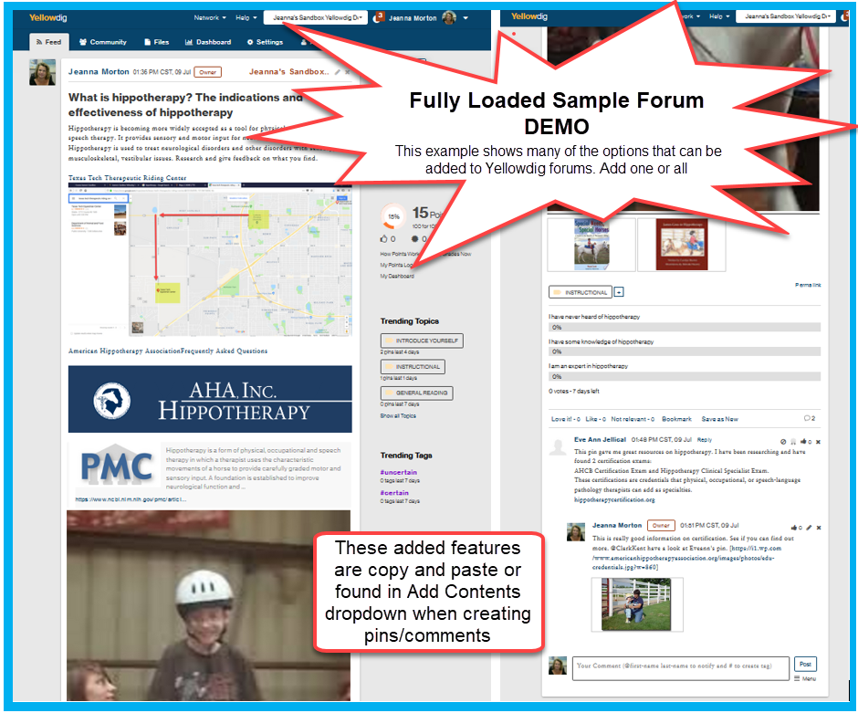

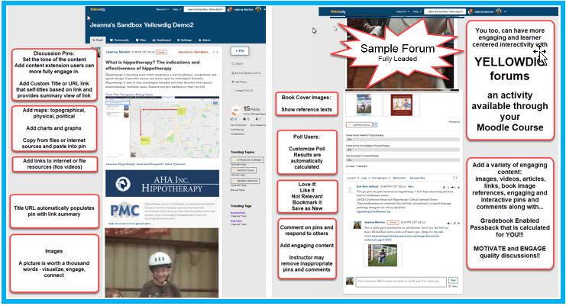

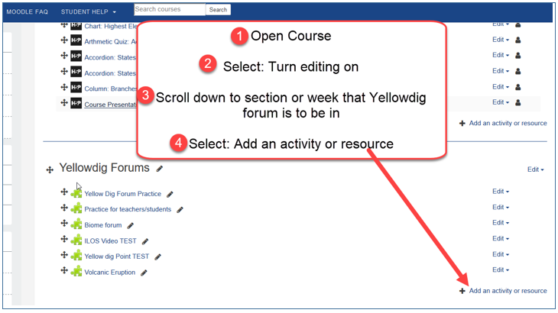

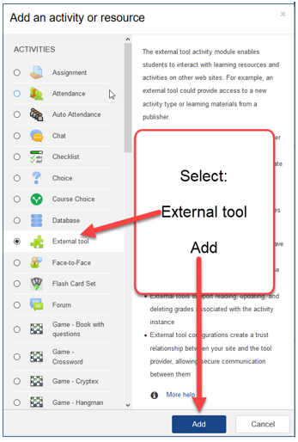

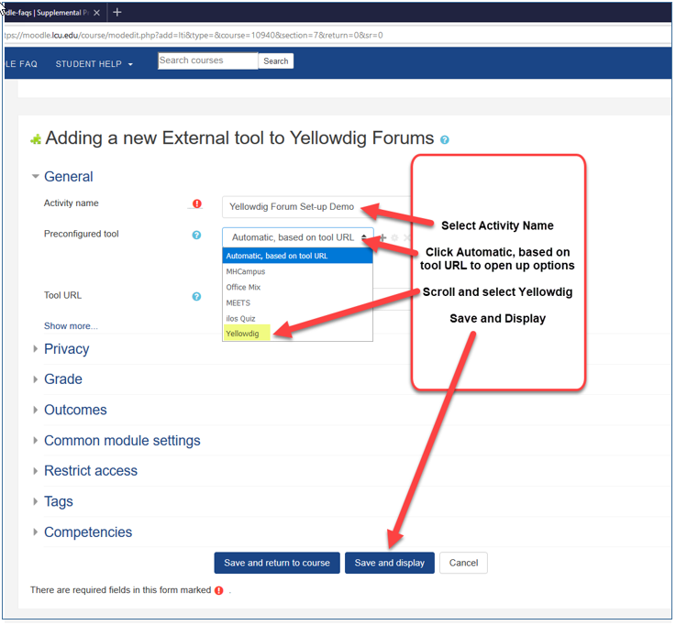

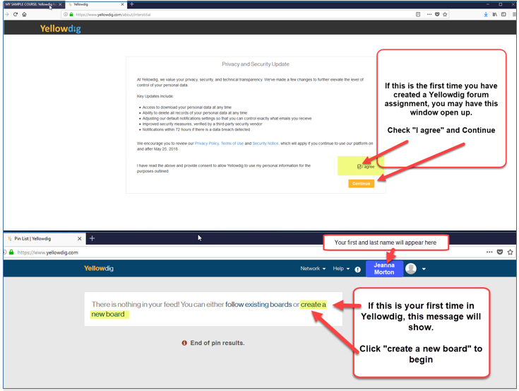

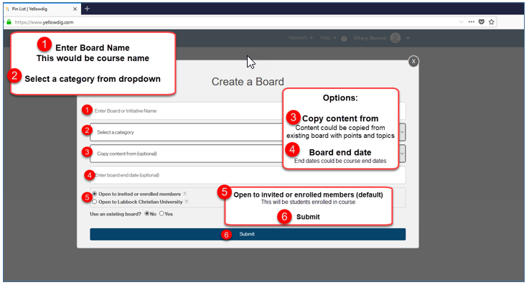

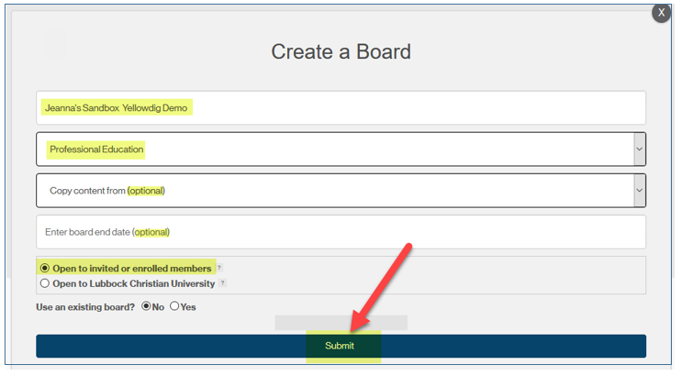

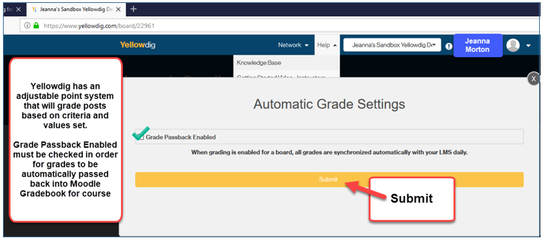

WARNING: When creating pins, Yellowdig intends that instructor pins be added each week, rather than all at once.

If you would like pin content to be created all at once, there are a couple of options:

1. Create pin content in a word document and then copy and paste pin content into Yellowdig each week. Content will be saved in Word and not have to then be recreated.
2. Create multiple pins in Yellowdig, but clearly Title “Week 1 Discussion, Week 2 Discussion…etc.”
   1. Make topics to match for easier use in locating pins (Users may click on topics to locate related pins)
   2. Keep in Mind - Pins will show in feed in order added, so if Pins are added chronologically: week 1, week 2, week 3, they will show in feed: week 3, week 2, week 1 (most recent entry on top of feed)

